**MODEL FOR INTELLIGENT GREENHOUSE**

*A thesis submitted in partial fulfillment of the requirements for*

*the award of the degree of*

**Master of Science**

in

**Computer Science**

by

**Soumodeep Dutta**

**17419CMP028**



**Department of Computer Science**

**Institute of Science**

**Banaras Hindu University, Varanasi – 221005**

**May 2019**

**CANDIDATE’S DECLARATION**

I, **Soumodeep Dutta** hereby certify that the work, which is being presented in the thesis/report, entitled Model for Intelligent Greenhouse, in partial fulfillment of the requirement for the award of the Degree of **Master of Science** in **Computer Science** and submitted to theinstitution is an authentic record of my/our own work carried out during the period January-2019 to May-2019 under the supervision of Prof. Vivek Kumar Singh. I also cited the reference about the text(s) /figure(s) /table(s) /equation(s) from where they have been taken.

The matter presented in this thesis as not been submitted elsewhere for the award of any other degree or diploma from any Institutions.

**Date: Signature of the Candidate**

This is to certify that the above statement made by the candidate is correct to the best of my/our knowledge.

**Date: Signature of the Research Supervisor**

The Viva-Voce examination of Soumodeep Dutta, M.Sc. Computer Science Student has been held on _________________.

|  |  |  |
| --- | --- | --- |
| **Signature of** |  | **Signature of** |
| **External Examiner(s)** |  | **Head of the Department** |

# ABSTRACT

The greenhouse is an important aspect of agriculture where crops are grown in a controlled microenvironment. But the environmental condition of the greenhouse needs to be continuously monitored for preserving the optimal condition best suited for a crop’s growth. Controlling all the artificial environmental condition has always been challenging. This is where the role of IOT comes to play. We can easily automate a system which will not only supervise the environmental parameters within a greenhouse but also regulate it. This is achievable through sensors and actuators. Sensors continuously read the environment parameters and any change from the optimal (threshold) can be counteracted by activating suitable actuators. The proposed algorithm observes temperature, humidity level and soil moisture and presence of ambient light and compare them with the optimal value for a particular crop and aims in maintaining it throughout the crop cycle. The entire system is automated which enables the greenhouse to sustain without any human intervention. Moreover, the farmer in a remote region also gets a notification regarding the automation happening inside the greenhouse, which he can easily access using a mobile application.

*Index Terms*—Internet of Things, Smart controllers, Sensors, Remote Sensing, Automation, Greenhouse Monitoring and Control.

**ACKNOWLEDGEMENT**

I would first like to thank my thesis advisor Prof. Vivek Kumar Singh of the Department of Computer Science at Banaras Hindu University. The door to Prof. Vivek Kumar Singh office was always open whenever I ran into a trouble spot or had a question about my research or writing. He consistently allowed this paper to be my own work, but steered me in the right the direction whenever he thought I needed it.

Finally, I must express my very profound gratitude to my parents and to my friends for providing me with unfailing support and continuous encouragement throughout my years of study and through the process of researching and writing this thesis. This accomplishment would not have been possible without them. Thank you.

**TABLE OF CONTENTS**

**Title Page No.**

ABSTRACT……………………………………………………………………...iii

ACKNOWLEDGEMENT………………………………………………………..iv

LIST OF FIGURES ..……………………………………………………………vii

LIST OF ABBREVIATIONS …………………...……………………………..viii

1. INTRODUCTION………………………………………………………….1

1.1 General………………………………………...………………….…...1

1.2 Objectives……………………………………………………………...1

1.3 Organisation of Report………………………………...………………2

2. LITERATURE REVIEW 3

3. IOT ECOSYSTEM 6

4. PROPOSED WORK 7

5. HARDWARE COMPONENTS 8

5.1 Control System………………………………………………………...8

5.2 Sensors………………………………………………………………..10

5.3 Actuators……………………………………………………………...13

6. SYSTEM ARCHITECTURE 14

7. PROCEDURE 16

8. INFORMATION PROCESSING AND EXTRACTION 18

9. DECISION MAKING 20

10. CONCLUSION AND DISCUSSION 21

11. REFERENCES 22

12. PLAGARISM REPORT……..…………………………………………….25

# LIST OF FIGURES

Fig. 1 Arduino Uno 8

Fig. 2 Raspberry Pi 9

Fig. 3 DHT11…………………………………………………………………….10

Fig. 4 MQ2 Sensor 10

Fig. 5 Soil-Moisture LM-393 11

Fig. 6 LDR LM-393 12

Fig. 7 Relay Switch 13

Fig. 8 Hardware Components 14

Fig. 9 Relay Circuit………………………………………………………………15

Fig. 10 Figurative Overview 16

Fig. 11 The Two-Way Data Transfer 16

Fig. 12 Block Diagram…………………………………………………………….19

# LIST OF ABBREVIATIONS

**Abbreviation Description**

**IOT Internet of Things**

**UID Unique Identifiers**

**GSI Global Standards Initiative**

**LDR Light Dependent Resistor**

**WSN Wireless Sensory Network**

**PA Precision Agriculture**

**GPS Global Positioning System**

**CSV Comma-Separated Values**

**VCC Voltage at the Common Collector**

**GND Ground**

**ICT Information and Communications Technology**

**USB Universal Serial Bus**

**GPIO General Purpose Input Output**

# INTRODUCTION

## GENERAL

In the present world where every person is always in transit, they need to have access to all of their devices all the time. The solution comes with the devices having an internet connection so that it can be accessed from everywhere around the globe. This is what resulted in we call “internet of things”. In the year 1999, the term “internet of things” was coined by Kevin Austin, the executive director of the Auto-ID[1]. From then IOT is in its ever-growing stage.

In general, IOT consist of anything and everything that uses some embedded technology to communicate with each other. IOT is an ecosystem of interrelated processing devices, mechanical and digital machines, physical objects, animals or people that have particular unique identifiers (UIDs) associated with it and is able to transfer information over the network without requiring person-to-person or person-to-devices communication[2].

IOT has impacted every sphere of day to day life. According to the Gartner 2018 Hype Cycle of Emerging Technologies, IOT is current at ‘Peak of Inflated Expectation’ phase. Also, the total economic impact of IoT in industrial worksites and factories in 2025 will be $1.3T-$4.6T as proposed by McKinsey. In 2013, the Global Standards Initiative on Internet of Things (IoT-GSI) defined the IoT as “the infrastructure of the information society.” [3] It is predicted that by the year 2020 there might be more than 26 billion IoT devices connected. As said the rule of IOT is that, "Anything that can be connected, will be connected."[4].

## OBJECTIVES

Agriculture plays a major role in a country like India. One of the modern sectors of agriculture is a greenhouse, where crops are grown in a controlled artificial environment. It is said a greenhouse optimal condition can increase a crop’s yield by 10 to 12 times. It also enables to grow off-season fruit and vegetable crop which are not only diseases-free also requires less water, chemical fertilizer, and pesticides than an open field crop. More than 50 countries worldwide had undertaken cultivation of crops on a commercial scale, which means they need high-quality reliable product all through the year. This is plausible by using greenhouse agriculture.

A greenhouse is an enclosed zone that produces a different environmental condition to that found outside due to the confinement of the air and to the absorption and trapping of short- wave solar radiation through a plastic or glass covers. This creates a new atmosphere inside the greenhouse which is better known as microclimate. The greenhouse microclimate can be altered by control actions, such as ventilation, heating, supplying adequate water to name a few; in order to provide suitable environmental conditions. In every country, there are thousands of hectors of greenhouse area available. Monitoring and control of the greenhouse environment are of utmost importance which needs to be done all 24 hours. This is done by human labor. Where every greenhouse needs people for 24 hours maintenance. Here comes the role of IOT which can monitor, control and automate a greenhouse environment in real time[5]. It can also minimize crop disaster and increase production.[6], [7]

In this paper, we are going to present a model for the implementation of a smart greenhouse environment with the help of IoT devices that can monitor and control the microclimate inside the greenhouse. Sensors such as temperature (DHT11 sensor), humidity, soil moisture, ambient light (LDR sensor), etc are used. The main aim is to reduce the cost as per power and resources and get a better yield but using those resources optimally. The greenhouse will also module itself for the type of crop it will be going to for using the specific requirement of the crop. The greenhouse can be fully-controlled from a remote region through the internet and thus promoting remote farming.

## ORGANIZATION OF THE REPORT

The rest of the paper constitutes of the literature review in the same topic in section 2, IOT components used in Section 3, the proposed work in section 4, hardware components used in section 5, section 6 contains the system architecture, section 7 has the pseudo-algorithm, section 8 with information processing and extraction, section 9 constitute the decision making, finally concluding this paper in section 10 with the discussion and section 11 with the list of references.

# LITERATURE REVIEW

**Joaquín Gutiérrez** et.al [8] have developed an automated irrigation system to optimize water use for agricultural crops. Distributed WSN has been used that monitors the soil moisture and temperature in the root region of the vegetation. Using the threshold values of temperature humidity of soil an algorithm was developed and coded into a microcontroller-based gateway to regulate water supply. 90% saving of water compared to traditional irrigation practice was achieved when this system was tested on sage crops for 136 days. Since the system uses photovoltaic cells, it can be implemented in geographically isolated areas with limited water supply.

Another work done by **R. Nageswara Rao** et.al [9] developed a system whose goal is using a low quantity of water for crop development. The suggested model estimates the water required using the calibrated information sent from the sensors that have been used to monitor the soil humidity condition and temperature as well as the duration of sunshine per day. This system has implemented Precision Agriculture (PA) with cloud computing, that optimizes the usage of water fertilizers all the while maximizing the yield of the crops as well as helping in analyzing the weather conditions of the field.

A project done by **N.Suma** et.al [10] includes various features like GPS based remote controlled monitoring, leaf wetness, temperature and moisture sensing, proper irrigation facilities, intruders scaring, security, etc. WSNs have been used for noting the soil properties and environmental factors continuously. The parameters that are being observed are controlled through remote devices or internet services and the operations are performed by interfacing sensors, Wi-Fi, a camera with a microcontroller. This project has been developed for farmer welfare.

In another work done by **Shaik Jhani Bhasha** et.al [11], the system monitors the water feeding activity in fields. This mechanism has been successfully implemented using PIC16F877A microcontroller, GSM module, water level sensors and a mobile phone with other necessary electronic devices and using these technology water motor can be turned on or off by farmers remotely.

**Mohanraj I** et.al [12] proposed an e-Agriculture Application based on the framework consisting of KM-Knowledge base and Monitoring modules. They focus on monitoring the data in the farming cycle so that it can advise the farmers to make profitable decisions. The paper demonstrates the advantages of ICT in the Indian agricultural sector.

Using WSNs with remotely controlled IP cameras **Hui Chang** et al [13] suggested an agriculture monitoring system. Temperature and humidity are mainly observed by conventional WSNs, while the design presented here integrates video of the foliage as well as information about the various environmental condition.

Nowadays precision agriculture is being used to improve efficiency and productivity in the usage of resources, thus helping to deal with the problems faced in agriculture due to climate change conditions, land quality, availability of space and labour force, etc. **Sangeetha A** et al [14] developed a decision support system based on the combination of the wireless sensor and actuation network technology to support the irrigation management in agriculture for farmers in developing countries using Li-Fi technology, topology and routing protocols.

Network-embedded greenhouse monitoring and control system is a small-size tightly coupled network of information system components like sensors, actuators, etc with limited accuracy.

**Stipanièev** et al [15] used the 1-wire protocol and embedded web servers to develop network embedded greenhouse monitoring and control. The experimental system has been developed using Tiny Internet Interface (TINI) which collects data from local sensor networks and route them to the global network using the web servers and in order to activate the actuators, it uses 1-wire local network. The major advantages of Network Embedded System Technology like changing physical topology, low cost and space requirement wrt to PC based systems while maintaining the complete functionality has been achieved by the system.

**Yunseop Kim** et al [16] designed a system for variable rate irrigation, WSN and real-time in-field sensing software and control of a site-specific precision linear-move irrigation system. Six in-field sensors were used to monitor field conditions site specifically depending on the soil property map. Programming logic used to control the irrigation machine also sends periodic georeferenced information of sprinklers to base stations. A user interface has also been developed for real-time monitoring of the variable irrigation rate.

**Shen Jin** et al [17] developed a remote measurement and control system for a greenhouse using GSM-SMS. The architecture comprises of central station and base stations. The central station manages the GSM module and database system while the base stations sensors, microcontroller, the operation administer, and the GSM module. The design also uses embedded operating systems which make it easy to extend the system, maintenance, etc.

# IOT ECOSYSTEM

1. **Smart devices and sensors**: These constitute the Things in the IoT ecosystem. These things can be anything starting from a cell phone to sensors like temperature, humidity, etc. which are interconnected with each other. [18]  
Here we have used sensors like the MQ2 sensor, LDR sensor, DHT11 (temperature and humidity) sensor, and a soil moisture sensor. Reading from these sensors will be the deciding factor to use the actuators like the water pump, exhaust fan, Peltier module, and artificial light.

2. **Gateway**: This layer works on analog data of devices and sensors are converted into a format that is easy to read and analyze in real time and also ensures security. Its main aim is to smoothen the bi-directional data flow between the sensors, protocols, and networks. It also converts analog input to percentage and sends them for processing.

We use Arduino Uno as the gateway platform from where the data from the sensor is directed to the raspberry pie.

3. **Processing**: The large bulk of data created is managed, handled and processed in this layer. This is where all the decision takes place. It can be called as the “brain” of the IOT ecosystem. It can be connected to a database to store the real-time data obtained from the sensors to get a historical overview of data.

Here Raspberry Pi 3 works as the brain of this IOT Ecosystem. The UI and the sensors (through Arduino) send data and accordingly, it performs a corresponding task, like changing the state of an actuator.

4. **User Interface**: It is the topmost layer of an IOT system visible and used by the user. It can be anything like a Web-Based Platform which will display the real-time data to the user also allow to regulate the functionalities of the IOT Ecosystem.

Here we use HTML, CSS to design the UI and jQuerry for adding functionality. This website is hosted using a Python library FLASK.

# PROPOSED WORK

The model is a miniature model of a working greenhouse environment monitored and controlled in real time. An agricultural environment parameter consists of temperature, humidity, soil moisture, and ambient light present; these all components can be monitored and artificially altered using IoT sensors and actuators, hence maintain a constant most optimal condition for a crop’s best yield. Moreover, these conditions will adapt itself no matter how harsh the outside condition is. Also, we can tune the system such that the environment condition inside the greenhouse can be altered automatically during each stage of the crop cycle and notify the user(farmer) about the current condition. The greenhouse environment can be made optimal for a specific crop with an easy-to-use web application. This promotes remote farming.

# HARDWARE COMPONENTS

For this IOT ecosystem, different hardware components are used. The details of each are listed below.

## CONTROL SYSTEM: -

* **Arduino Uno**: It is an open source processing device having the ATmega328P programmable microcontroller with a clock speed of 16 MHz with auto-reset. It takes a power input of 12V. It has a USB plug to upload or burn the program to the microcontroller.[19] It has a set of analog and digital pins where respective inputs/outputs are fed into. Analog value is fed in by a relative voltage between 0 to 5V. On receiving an analog value from the sensor it converts the voltage to a 10-bit integer value (0-1023) then the percentile is sent to the raspberry pie raspberry for processing. The microcontroller sends data of all the sensors through the USB in CSV format. Fig. 1 shows the Arduino Uno. It forms the gateway for the IoT ecosystem.

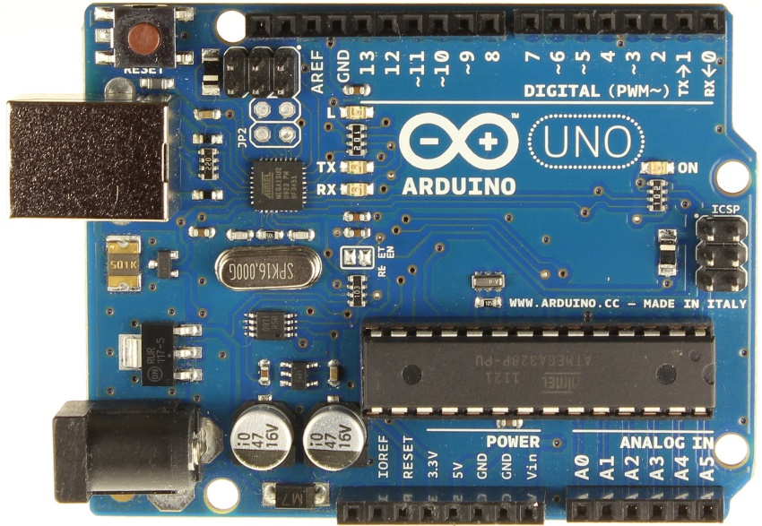

Fig. 1

* **Raspberry Pi 3**: The Raspberry Pi is a series of small single-board computers developed in the United Kingdom by the Raspberry Pi Foundation to promote the teaching of basic computer science in schools and in developing countries. The original model became far more popular than anticipated, selling outside its target market for uses such as robotics. It does not include peripherals (such as keyboards and mice) and cases. The model used in the project is a Raspberry Pi 3 Model B with 1.2 GHz 64-bit quad core processor,1 GB RAM, onboard Wi-Fi, Bluetooth, and USB boot capabilities. The Arduino Uno is connected to raspberry pie using USB, through which it gets the 5V power and also send the sensory data in CSV format. The Raspberry Pi runs a python script which continuously accepts the data with 1-second interval and also hosts a web-based service where the real-time data is displayed and also, we can tune the optimal(threshold) value for each sensor against which an actuator will be triggered. The actuators are directly controlled through the GPIO pin of the Raspberry Pi.[20], [21]

Fig. 2

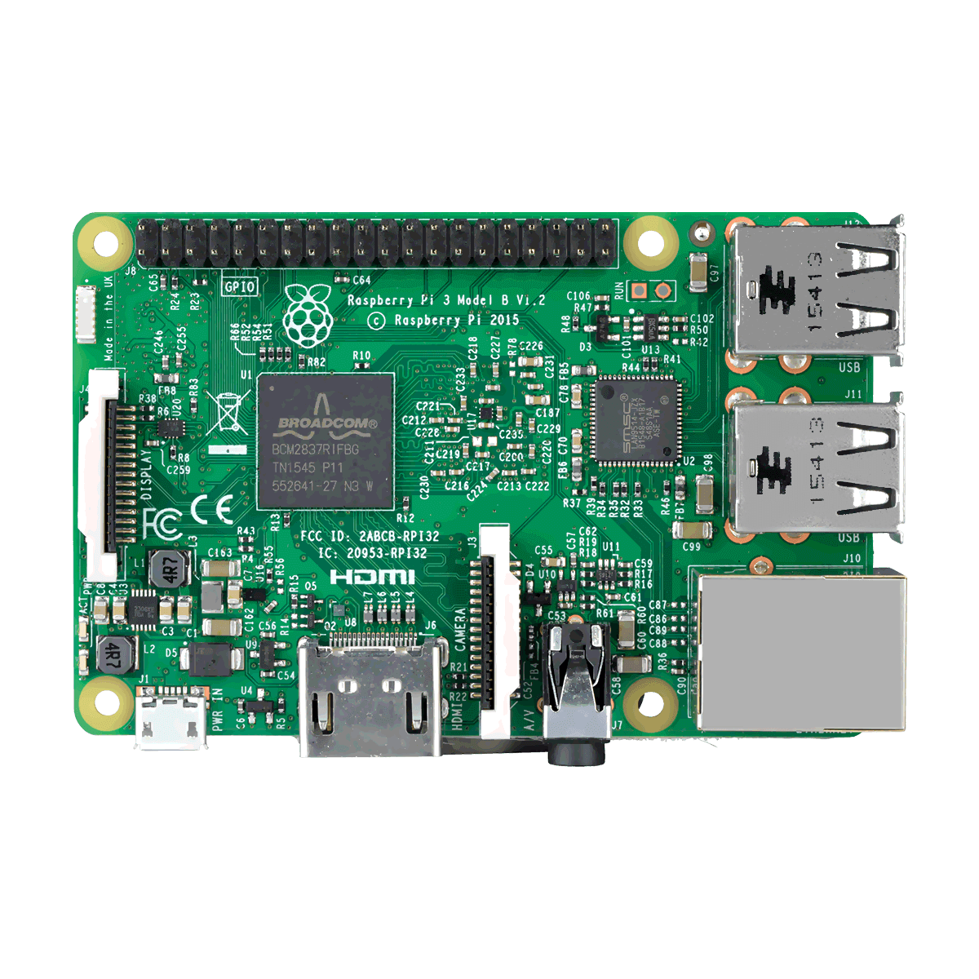

## SENSORS: Components which monitors the environment-

* **DHT11**: It is a low-cost temperature and humidity sensor requiring a 5V power supply. It has a range of 20-90RH for measuring humidity with ±5% accuracy and has a range of 0-50º C for measuring temperature with an accuracy of ±2º C. It uses two-way single wire serial interface. It has a three-stage communication consisting of the request, response, and data reading. It contains a thermistor whose resistance changes with the change in temperature. Also, humidity is measured with the help of two electrodes separated by a moisture holding substrate between them. So as the humidity of the atmosphere changes the resistances also changes and we can get the value using this formula.

Fig. 3 is a DHT11 sensor. [22],[23]

* For temperature sensing:   
   Temperature = (Vout * 100) / 5º C
* For humidity sensing:  
   Relative Humidity = ((Vout / Vsupply) - 0.16) /0.0062 %

Fig. 3

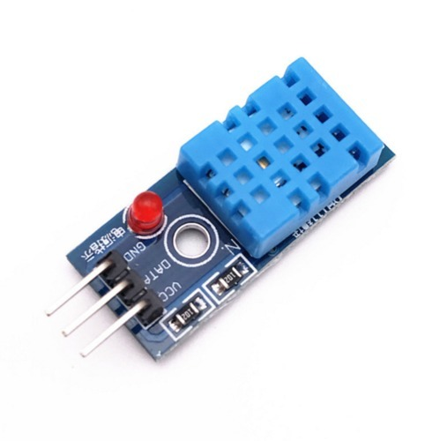

* **MQ2** **Gas Sensor**: It is a reliable and stable smoke sensor and has a low dependency on temperature and temperature humidity. It is useful for gas leakage. It is suitable for detecting H2, LPG, CH4, CO, Alcohol, Smoke or Propane. Due to its high sensitivity and fast response time, the measurement can be taken as soon as possible. The sensitivity of the sensor can be adjusted by the potentiometer. This module has both a digital and an analog output pin. [24]

Fig. 4

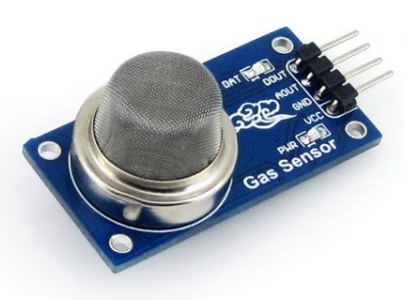

When the sensor exposed to gas or smoke, an electrolytic reaction occurs and gives us the approximated trend of gas concentration in the air. Having a potentiometer gives us the freedom to tune the correct sensitivity required for the system.

* **Soil-Moisture LM-393**: Soil moisture sensors measure the volumetric water content in the soil. It is a cost effect and reliable soil moisture content detection module that work on 5V supply. It consists of two metal rods (Fig. 5) held apart through which current passes. The resultant resistance is high when soil moisture is low and vice-versa. The module is fitted with a potentiometer that can vary the sensitivity of the sensor. [25]

Fig. 5

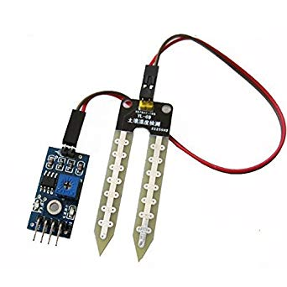

* **LDR LM-393:** An LDR is a component that has a (variable) resistance that changes with the light intensity that falls upon it. This allows them to be used to detect the presence of ambient light intensity in the environment. It uses Cadmium Sulphide for the registered material. The resistance of the LDR (light dependent resistor) changes with the change in intensity of light. The LM-393 module has both analog and digital output pin.[26]

Fig. 6

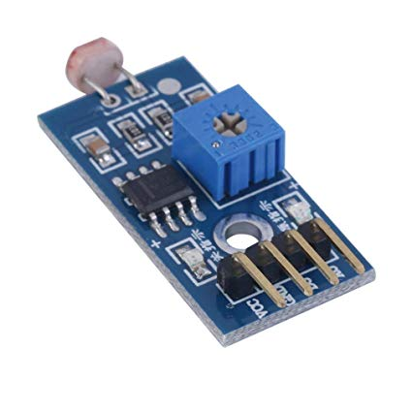

All these components sense the environment and provide the information to the Arduino Uno which in turn processes the data and convert into a percentage. This value is then forwarded to the cloud for further processing in CSV format.

## ACTUATORS: Components which control the environment-

* **Peltier Module**- This is a heating unit which will control and balance the temperature to achieve an optimum temperature in the greenhouse.
* **Exhaust Fan**- To control the temperature as per the standard level
* **Water Sprinkler**- To maintain the moisture level in the soil.
* **Artificial Light**- To provide artificial optimum lighting.

On receiving an active signal from the raspberry pi; it gets powered up and sets the environment inside the greenhouse best suited for optimum crop growth. The actuators are 12V electronic devices. As we know it is not possible to drive a 12V power supply through the raspberry pi so a relay switch is used.

Fig. 7

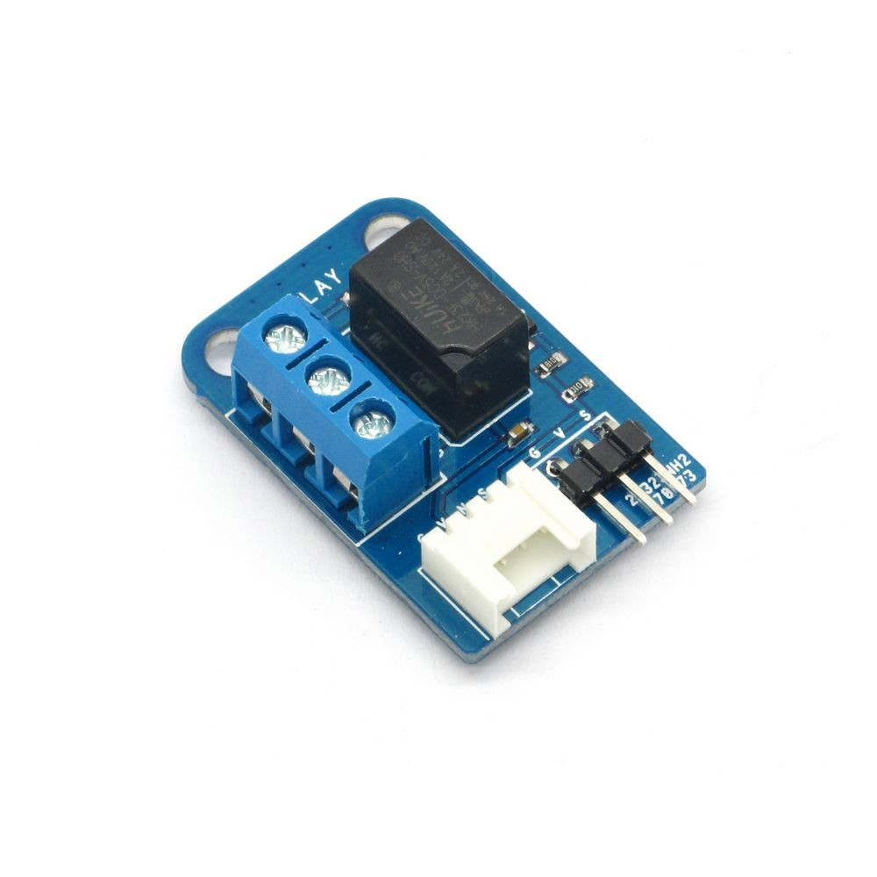

**Relay Switch:** According to Merriam-Webster, a relay is, “an electromagnetic device for remote or automatic control that is actuated by variation in conditions of an electric circuit and that operates, in turn, other devices (such as switches) in the same or a different circuit.” The heart of a relay is an electromagnet. It is switched on with a tiny current where the electromagnet is activated and it switches on another appliance using a much bigger current.[27]

# SYSTEM ARCHITECTURE

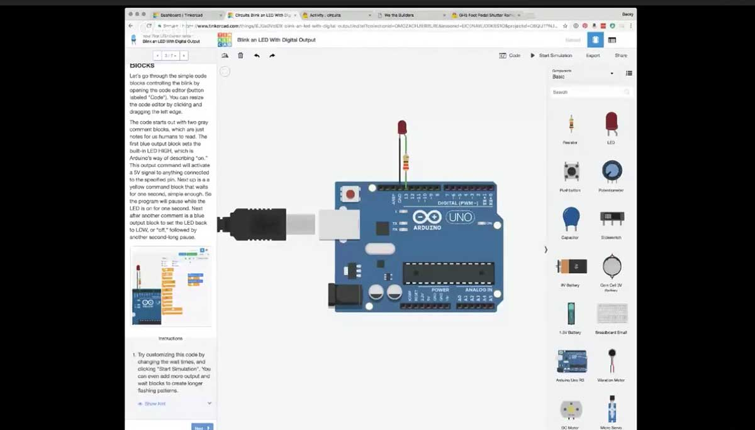

Fig. 8

Fig. 8 show the Sensory components of this system. Each sensor has a VCC, GND(Ground) pin which has to be connected with the +5V power out pin of Arduino and GND pin respectively. The entire system consists of two types of sensors:

1. Digital Sensor: DHT11 which uses two-way single wire serial interface
2. Analog Sensor: MQ2, LDR, Soil Moisture is generating a voltage in the range of 0-5V

These digital and analog sensors are directly connected to the respective pin in the Arduino, which acts as a sensor data collection pit. It collects this data and organizes it in proper digital CSV format to be sent to Raspberry Pi for processing every second.

The Arduino is connected to the Raspberry Pi via USB cable (through which it also gets its power). Raspberry Pi runs a python scripted listener to record the data sent from Arduino. Comparing this real-time sensory data to its previously set optimal value it makes a decision as to which actuator it must trigger. Accordingly, it sends a high signal through its GPIO pin which is connected with a relay. It acts as a switch to turn a particular actuator on/off. The relay is used because we cannot have a direct connection between the control circuit operating at 5V and the output device operating at 12V. The GPIO pin sends a switching signal to the relay which then completes the circuit and provides 12V power supply to turn on the specific actuator.

The Raspberry Pi needs to be powered using a 2A micro-USB, which in turn powers the relay circuit and the Arduino board.

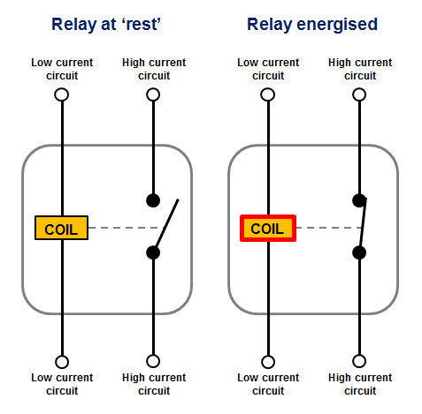

0 V

+5V

Fig. 9

# PROCEDURE

Fig. 10 shows the figurative overview as for how the system is going to function. Algorithm overview of the system is given below.



Sensors Arduino Uno Raspberry Pie Actuators  
Fig. 10

**RELAY**

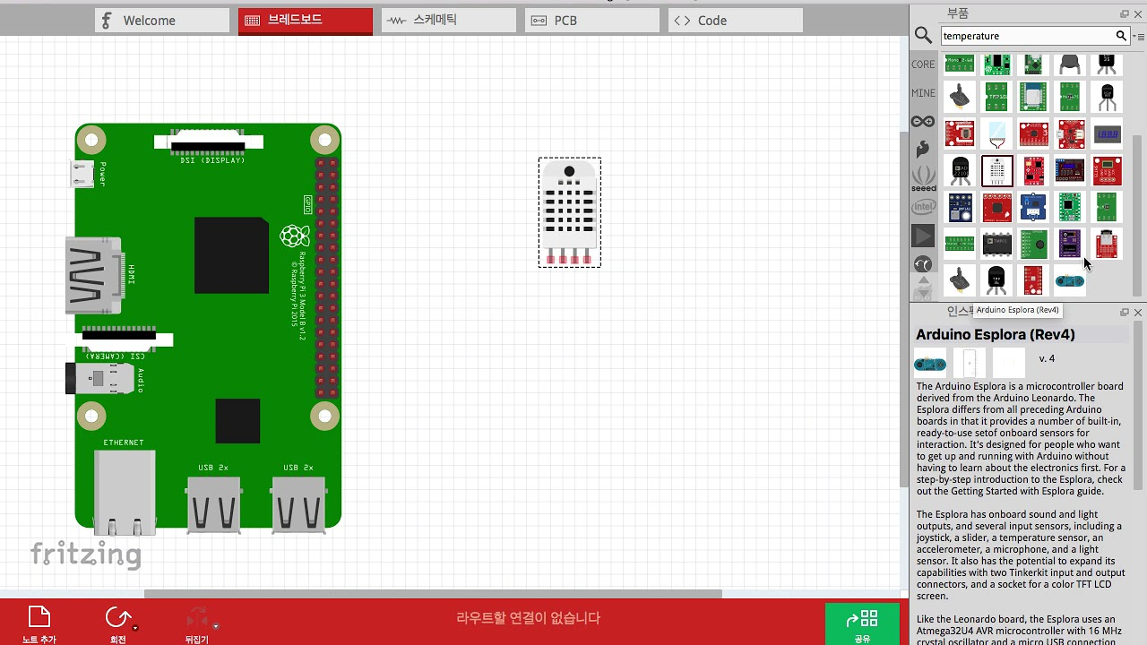

Fig. 11

**Start**

1. Arduino Uno acquires sensor data continuously connected through its input pins with 1-second interval.
2. Analog to Digital conversion of the sensor data on the Arduino Board.
3. All the sensor data are accumulated and converted to CSV format
4. Transmission of the data to the Raspberry Pi through USB.
5. Raspberry Pi running a python script continuously listens for incoming data.
6. Automation in Raspberry Pi - If the sensor data is above the threshold
   1. The Pi automatically Turns ON the control measure by sending a signal to the corresponding actuator.
7. Else If the data is within a threshold
   1. The Pi automatically Turns OFF the corresponding actuator or Turns ON another related actuator.
8. Else If Automation Turned OFF
   1. The user has full control over any of the actuators and can change its state using the web application
9. Continue checking for the threshold condition for each sensor, GOTO Step 5
10. Endif

**End**

# INFORMATION PROCESSING AND EXTRACTION

Input sensors (MQ2, LDR, Soil Moisture) provides the environment information in the form of analog voltage ranging from 0-5V and two-way single wire serial interface (for DHT11). These are directly connected to the Arduino Uno via its analog pin (indicated by orange in Fig. 8) or digital pin(indicated by blue in Fig. 8). The programmable microcontroller accepts analog data from the particular analog pins and the two-way single wired and converts it to digital data. The Arduino will map analog input voltages between 0 and 5 volts into integer values between 0 and 1023. These data are then processed and converted to a readable percentile which can easily be calculated or used as a reference for easier decision making. It then appends all the sensory data in digital format and sends it to Raspberry Pi (in CSV format) for analysis and decision making. This process is done by C++ program compiled for the Arduino Uno board using the Arduino IDE cross-compiler. The Arduino Integrated Development Environment (IDE) is a cross-platform application that is written in Java. It is used to write and upload programs to Arduino compatible boards. It supports C and C++ programming languages only.

Raspberry Pi on receiving the sensory data through USB, analyses it. It uses Python library Pyserial script to listen to the incoming data through a particular communication port (here "/dev/ttyACM0"). It has a set of optimal values that are set by the user through its UI. The necessary decision is made on the raspberry depending upon the optimal (threshold) value and necessary steps for control are sent for modifying the microclimate inside the greenhouse. It uses the Python library RPi.GPIO to send a high signal from its GPIO (General Purpose Input Output) pins. Each GPIO pins are connected to one of the actuators and a high voltage through the GPIO results in powering up the actuator and vice-versa. The GPIO pin is not directly connected instead a relay is used between them. The relay is used because we cannot have a direct connection between the control circuit operating at 5V and the output device operating at 12V. The GPIO pin sends a switching signal to the relay which then completes the circuit and provides 12V power supply to turn on the specific actuator.

The respective environment conditions are sent to the web application. The Raspberry pie also hosts the website using the Python library FLASK to display real-time micro-environment data on the port 5000. It also consists of control by which we can switch the actuators on or off manually under manual Automation, else under Active automation the actuator powers on/off depending on the environment condition (provided by sensory data). It is shown in Fig. 9 the two-way data transfer from hardware components to Raspberry and the UI.

For example, in the developed system a threshold value for temperature is kept at 25 ◦C. Whenever the temperature goes below the threshold temperature, the database will trigger action to the decision logic. It will then turn on the Peltier module to heating mode.

ARTIFICIAL LIGHT

EXHAUST FAN

WATER PUMP

PELTIER MODULE

REMOTE DESKTOP

REMOTE MOBILE

ANALOG / DIGITAL PINS

RELAY MODULE

ARDUINO UNO   
  
MICRO-CONTROLLER

RASPBERRY PI 3  
MODEL B



Fig. 12

GPIO PINS

USB PORT

# DECISION MAKING

|  |  |
| --- | --- |
| IF | THEN |
| Soil moisture level low | Turn on the water sprinkler |
| Soil moisture level ok | Turn off the water- sprinkler |
| Gas conc. high | Fire Alert |
| Temperature high | Turn on the Exhaust |
| Temperature low | Turn on the Peltier module to heat up mode |
| Ambient light low | Turn on Artificial light |
| Ambient light OK | Turn off Artificial light. |

# CONCLUSION AND DISCUSSION

This paper provides a model for an intelligent greenhouse its architecture and functionality. It depicts the benefit of using IoT in agricultural sector mainly in the greenhouse. Contrary to the other models where traditional monitoring analog systems are used, we not only monitor the parameters of the environment but also regulate them using actuators. In our proposed system we have been using 5 parameters but in fact, the count is endless. We can include fertilization and pest removal module in this same model. We can also improve the model by using IP cameras that can be used for monitoring purpose also using image processing we can detect any kind of diseases in plants, the yield rate of a plant and much more. Also, a module to check the quality and type of soil and recommend the crop best suited for this soil can be integrated that will benefit the farmer. The cloud can be used for data processing and analysis we can monitor and analyze the sensor data, and access historical data easily.

The sensors and microcontroller are successfully interfaced and wireless communication is achieved between various nodes. All observations and experimental tests prove that this project is a complete solution to field activities and irrigation problems not only in a greenhouse but also in an open agricultural field. Implementation of such a system in the field can definitely help to improve the yield of the crops and overall production. All of these are low cost, low power sensors which can enable a to maintain, monitor and control any number of greenhouses sitting in any corner of the globe as long as he has active internet connectivity within them.

# REFERENCES

[1] Ashton K., “That ‘Internet of Things’ Thing,” *RFID J.*, p. 4986, 2009.

[2] “What is internet of things (IoT)? - Definition.” [Online]. Available: https://internetofthingsagenda.techtarget.com/definition/Internet-of-Things-IoT. [Accessed: 10-Dec-2018].

[3] J. Gubbi, R. Buyya, and S. Marusic, “Internet of Things (IoT): A Vision, Architectural Elements, and Future Directions,” *Atmos. Environ.*, no. 1, pp. 1–19, 2013.

[4] Jacob Morgan, “A Simple Explanation Of ‘The Internet Of Things.’” [Online]. Available: https://www.forbes.com/sites/jacobmorgan/2014/05/13/simple-explanation-internet-things-that-anyone-can-understand/#557bed561d09. [Accessed: 10-Dec-2018].

[5] D. Liu, X. Cao, C. Huang, and L. Ji, “Intelligent agriculture greenhouse environment monitoring system based on IOT technology,” *Proc. - 2015 Int. Conf. Intell. Transp. Big Data Smart City, ICITBS 2015*, pp. 487–490, 2016.

[6] K. A. Patil and N. R. Kale, “A model for smart agriculture using IoT,” *Proc. - Int. Conf. Glob. Trends Signal Process. Inf. Comput. Commun. ICGTSPICC 2016*, pp. 543–545, 2017.

[7] G. Sushanth and S. Sujatha, “IOT Based Smart Agriculture System,” *Int. J. Recent Innov. Trends Comput. Commun.*, vol. 2, no. February, pp. 177–181, 2017.

[8] J. Gutiérrez, J. F. Villa-Medina, A. Nieto-Garibay, and M. Á. Porta-Gándara, “Automated Irrigation System Using a Wireless Sensor Network and GPRS Module,” *IEEE Trans. Instrum. Meas.*, 2013.

[9] R. Nageswara Rao and B. Sridhar, “IoT based smart crop-field monitoring and automation irrigation system,” *Proc. 2nd Int. Conf. Inven. Syst. Control. ICISC 2018*, no. Icisc, pp. 478–483, 2018.

[10] N. Suma, S. R. Samson, S. Saranya, G. Shanmugapriya, and R. Subhashri, “IOT Based Smart Agriculture Monitoring System,” *Int. J. Recent Innov. Trends Comput. Commun.*, vol. 2, no. February, pp. 177–181, 2017.

[11] S. J. Bhasha and S. M. Hussain, “Agricultural field monitoring and automation using PIC16F877A microcontroller and GSM.,” vol. 3, no. 6, pp. 2155–2157, 2014.

[12] I. Mohanraj, K. Ashokumar, and J. Naren, “Field Monitoring and Automation Using IOT in Agriculture Domain,” *Procedia Comput. Sci.*, vol. 93, no. December 2016, pp. 931–939, 2016.

[13] H. Chang, N. Zhou, X. Zhao, Q. Cao, M. Tan, and Y. Zhang, “A new agriculture monitoring system based on WSNs,” *Int. Conf. Signal Process. Proceedings, ICSP*, vol. 2015–Janua, no. October, pp. 1755–1760, 2014.

[14] A. Sangeetha, P. Sarah, and G. Poovarasi, “IOT BASED HYBRID SYSTEM FOR PRECISION AGRICULTURE MONITORING USING WSN INTO MODERN INFORMATION AND COMMUNICATION TECHNOLOGY ( ICT ),” no. 2, pp. 3116–3124, 2018.

[15] D. Stipanicev and J. Marasovic, “Networked embedded greenhouse monitoring and control,” *Control Appl. 2003. CCA …*, pp. 1350–1355, 2003.

[16] Yunseop (James) Kim, R. G. Evans, and W. M. Iversen, “Remote Sensing and Control of an Irrigation System Using a Distributed Wireless Sensor Network,” vol. 57, no. 7, pp. 1379–1387, 2008.

[17] J. Shen, J. Song, Q. Han, S. Wang, and Y. Yang, “A remote measurement and control system for greenhouse based on GSM-SMS,” *2007 8th Int. Conf. Electron. Meas. Instruments, ICEMI*, pp. 282–285, 2007.

[18] “What are the major components of Internet of Things - RF Page.” [Online]. Available: https://www.rfpage.com/what-are-the-major-components-of-internet-of-things/. [Accessed: 12-Dec-2018].

[19] “Arduino Reference.” [Online]. Available: https://www.arduino.cc/reference/en/. [Accessed: 16-Dec-2018].

[20] H. Chaudhari, “Raspberry Pi Technology : A Review,” *Int. J. Innov. Emerg. Res. Eng.*, vol. 2, no. 3, pp. 83–87, 2015.

[21] A. K. Kyaw, H. P. Truong, and J. Joseph, “Low-Cost Computing Using Raspberry Pi 2 Model B,” vol. 13, no. 3, pp. 287–299, 2017.

[22] Mouser Electronics, “DHT11 - Humidity and Temperature Sensor,” *Datasheet*, pp. 1–7, 2011.

[23] J. He, J. Qu, Y. Wang, and H. Pan, “The designing and porting of temperature &humidity sensor node driver based on ARM-Linux,” *Proc. - 2014 IEEE Work. Electron. Comput. Appl. IWECA 2014*, pp. 127–130, 2014.

[24] B. B. L. Heyasa and V. R. K. R. Galarpe, “Preliminary Development and Testing of Microcontroller-MQ2 Gas Sensorfor University Air Quality Monitoring,” *IOSR J. Electr. Electron. Eng.*, vol. 12, no. 03, pp. 47–53, 2017.

[25] Datasheet, “LMx93-N , LM2903-N Low-Power , Low-Offset Voltage , Dual Comparators,” no. 1, 2018.

[26] J. Ahmad and R. Yousuf, “Light Dependent Resistor (LDR) Based Low Cost Light Intensity Measurement Circuit Design (LUX Meter),” *Int. J. Innov. Res. Comput. Commun. Eng. (An ISO Certif. Organ.*, vol. 3297, no. 3, pp. 14735–14739, 2007.

[27] P. Zabala, “Development of Programmable Relay Switch Using Microcontroller,” *Am. J. Remote Sens.*, vol. 5, no. 5, p. 43, 2018.

# PLAGARISM REPORT

